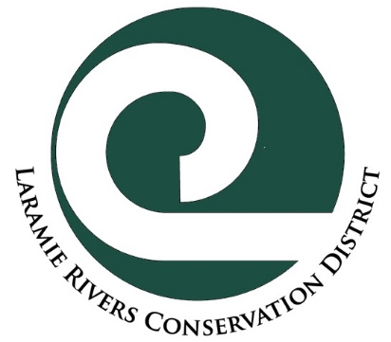
Laramie Rivers Conservation District
Living Snow Fence Cost Share Program
General Program Objectives
The LSF Cost Share Program promotes planting living snow/windbreak fences as conservation tools. LRCD provides planning, supplies and labor for the planting of living snow/windbreak fences.

Who is Eligible:
Albany County residents with 5 or more acres and a reliable source (quality and quantity) of irrigation water.
Specific Goals of Program
Manage snow deposition
Livestock shelter
Energy conservation via wind protection
Enhance wildlife habitat by providing food and cover
Noise reduction
Enhance beautification/aesthetics of property/community

Funding
The Cost Share Program matches up to 50% of project costs. This is a reimbursement of cost paid to the applicant after the project is complete.
- Before work begins, the application will require board review and approval
- Maximum match is 50% of project cost, up to $1,000.
- Cannot be used to fund landowner labor costs.
- LRCD encourages making purchases within Albany County when possible.
- Applicants can apply once per calendar year (January 1st to December 31st ).

Selection Process
The Laramie Rivers Conservation District Board of Supervisors makes all grant authorizations and payment decisions. When necessary, they will suggest or require project plan changes based on their experience and knowledge of best practices.

Criteria for Cost Share
For a project to be eligible for LRCD cost share funds, a project must:
- Clearly meet objectives of this program.
- Allow LRCD staff to take before/after photographs.
- Meet all applicable standards and codes of federal, state, city and/or county government, and be agreeable with grant recipient’s neighbors.
- Be fully completed within one year of approval.
- Be approved on a first-come, first-served basis.
- Be approved by LRCD Board of Supervisors before work commences or material is purchased.

Application and Program Procedure
- Self-assessment: does your proposed project meet the objectives of this program?
- Arrange for LRCD staff on-site visit to determine if project meets the criteria.
- LRCD Board of Supervisors reviews and authorizes Application/Agreement during the monthly meeting, typically the third week of each month.
- Upon approval, complete the project as described in application.
- When project is finished, arrange for LRCD staff to inspect work, take photographs, and sign Agreement Completion Certification.
- Turn in: 1) receipts; 2) reimbursement worksheet; 3) tax form, if required; 4) and signed Agreement Completion Certification.
- LRCD Board of Supervisors reviews completed project and authorizes reimbursement.
- You should receive reimbursement check by mail within 15 days of monthly board meeting.
- After project has been finalized, applicant is encouraged to attend a Board of Supervisors meeting and present their project.
THE LRCD BOARD OF SUPERVISORS RESERVES THE RIGHT TO DECIDE WHETHER PROPOSED COSTS ARE REASONABLE AND WHETHER A PROJECT DESIGN IS APPROPRIATE.

Laramie Rivers Conservation District
Living Snow Fence Cost Share
Application and Agreement Form

Cooperator Name: ____________________________________________________ Date: _________________

Mailing Address: ___________________________________________________________________________

Project Address: ____________________________________________________________________________

Phone: ____________________________________ Email:__________________________________________

Project description (please attach design and technical plans if you have any):

Estimated project total: $ Attach detailed budget-LRCD does not cost share on the sales tax

50% cost share request: $
Staff comments:
Public benefit:  conservation of natural resources  protection or enhancement of wildlife habitat
 beautification of public space  promotion of health/safety of citizens
 protection of the tax base

I affirm that the application information provided is accurate, to the best of my knowledge, and I have read and understand the Cost Share Program Agreement.

__________________________________________________________ Date:_________________________
Signature of Applicant

__________________________________________________________ Date:_________________________
Signature of LRCD staff preparing application

Date Approved by Board:_________________________

PURCHASES MADE BEFORE APPROVAL MAY NOT BE ELIGIBLE FOR COST SHARE!

PLEASE NOTE THAT COST SHARE FUNDS MAY BE SUBJECT TO FEDERAL INCOME TAX!

__________________________________________________________________________________________
Agreement Completion Certificate (must be signed prior to payment)
I hereby certify that implementation of the conservation practices proposed in the Application/Agreement have been completed according to the Objectives and Criteria of this program as of the date shown below. The receipts I provided reflect the true cost of implementing the project authorized.

__________________________________________________________________________________________
Signature of Applicant Date

_______________________________________________ Date Reimbursement Approved:_______________________
Project checked by LRCD staff Date

